EC2 Instance Creating steps:

=============================

->Create EC Instance by following below steps:

Note: You should have AWS account , should login and goto All services

Step-1

Goto 🡪 All Services -> Select EC2 service

Click launched button

Step2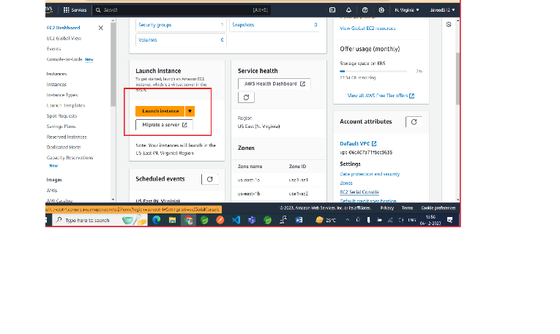

Enter Name and Tags

Name [springboot-aws-example]

Select O.S / Amazon Machine Image (AMI)

Select default eligible for free tier. Ex: Linux O.S / Linux AMI

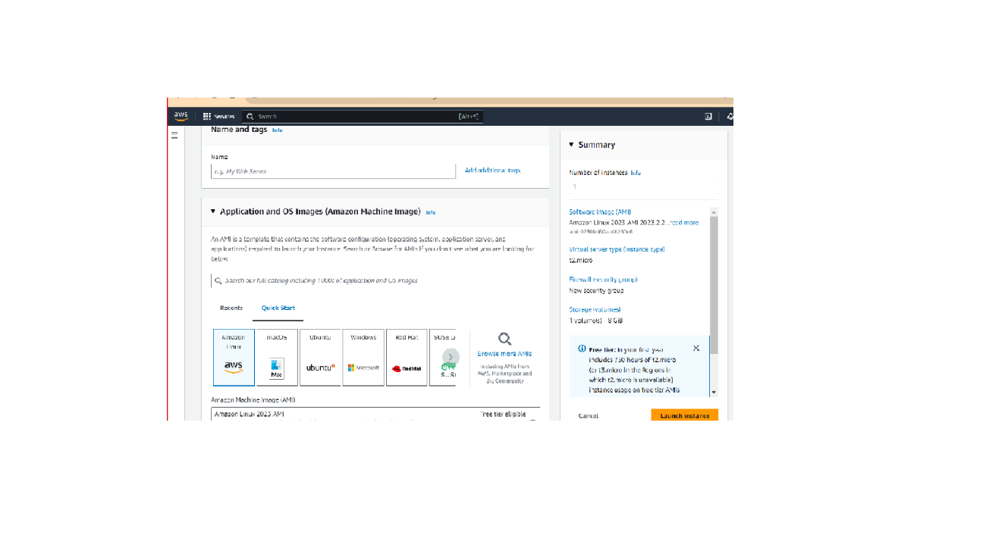

Step3

Select Instance Type default eligible for free tier

Step4

Create key pair (for login purpose)

Write any keypair name and generate key pair

Note: It will generate key-pair in .pem file format (private key)

Keypair name = springboot-aws

Generated File wil be : springboot-aws.pem

After key pair generate just select or keep default things and launch EC2 instance

By clicking launch button.

Remember if we want to connect from local O.S /Machine to EC2 Instance (AMI) we need putty software

Download and install putty in windows , which also intall puttyGen automatic

Now, open puttyGen and load pem file to generate ppk file

springboot-aws.pem 🡪 springboot-aws-key.ppk

Now, open putty software and copy HostName from EC2 instance connect page.

Inside EC2 Instance details page we find some host name like below

ec2-100-24-49-87.compute-1.amazonaws.com

copy this into HostName in putty window

Then , open Data option inside putty window and write username from EC2 Instance

Ex: ec2-user is default username or we can write custom user name by clicking connect option under ec2 instance page.

SSH option and Goto Auth 🡪 select credentials 🡪 Browse private key file here and open it

Finally it will connect with EC2 Instance from local machine to AWS EC2 Instance / AMI

Once we connect to EC2 AMI from local machine we can install any thing like Java , Mysql , Angular etc.

https://springboot-aws-bucket.s3.amazonaws.com/springboot-0.0.1-SNAPSHOT.jar